**UWB CSS 490A - Intro to Cloud Commuting**

**Quiz Project – Nov 16th 2015**

**Duration – 1 Hour and 50 Mins**

In this Quiz Project, you will build a Book-Club inventory app using ASP.net MVC Web Application template. An individual book belonging to this Book club will have the following properties:

1. ID Integer (for MVC internal use)
2. Title String
3. Author String
4. Publication Year String
5. Genre String
6. CheckedOutID String

When the user starts the app the top navigation bar should have three menus:

1. BookClub (AppName)
2. Home
3. Search

AppName menu will take the user to Home view page.

The app starts with the “Home” view page. Home page should list all the books in the inventory (see the bitmap for Home view below). Home page has the link to add new books to the club (“Create New”). Below it, the home page shows the inventory of the books including “club member” whom an individual book is currently checked out to and blank if in the club. Also note that “Checkout” command shows up only on those books that are available to be checked out and “Return” command on those that are currently checked out.

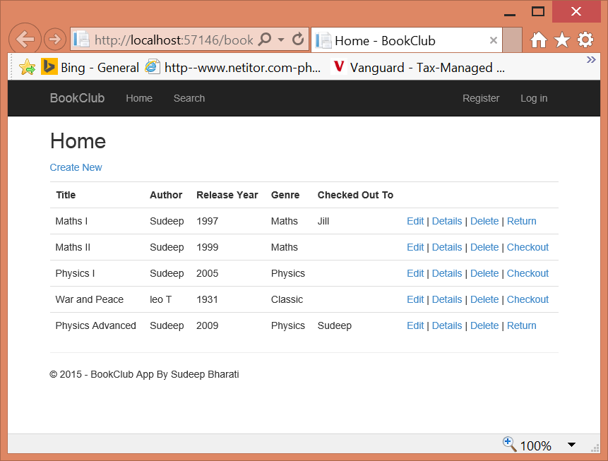

On clicking “Return” command, the app update the checked out status of that book and simply erases the associated “Checked Out To” entry and reverts to the home view (shown in the next bitmap on clicking “Return” on “Maths I” book entry).

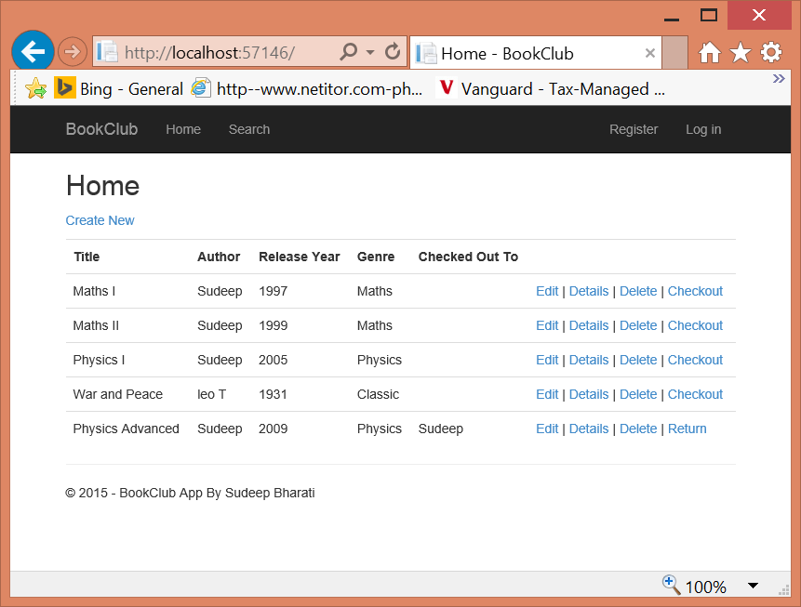

On Clicking Checkout, the app should take the user to a Checkout page where the member name will be provided by the user and then the book will be checked out to that member (See below bitmap where “Checkout” command was clicked with “War and Peace” book entry.)

Note that this view shows the name of the book in the text that is being asked to be checked out:

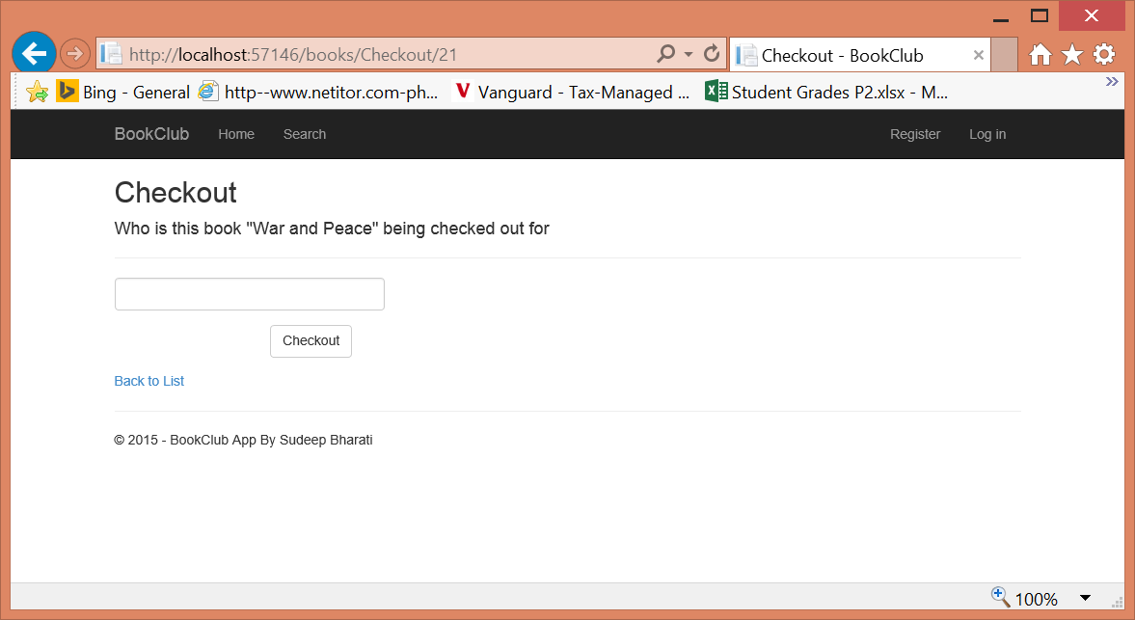

On typing a member name and clicking out the Checkout button should take the user back to Home view with “War and Peace” showing “Checked Out To” field appropriately updated.

Next are Create and Edit views. Note that these views only show book entries to be filled-in. “Checked Out To” field is not handled here as that is being taken care of in “Checkout” and “Return” commands.

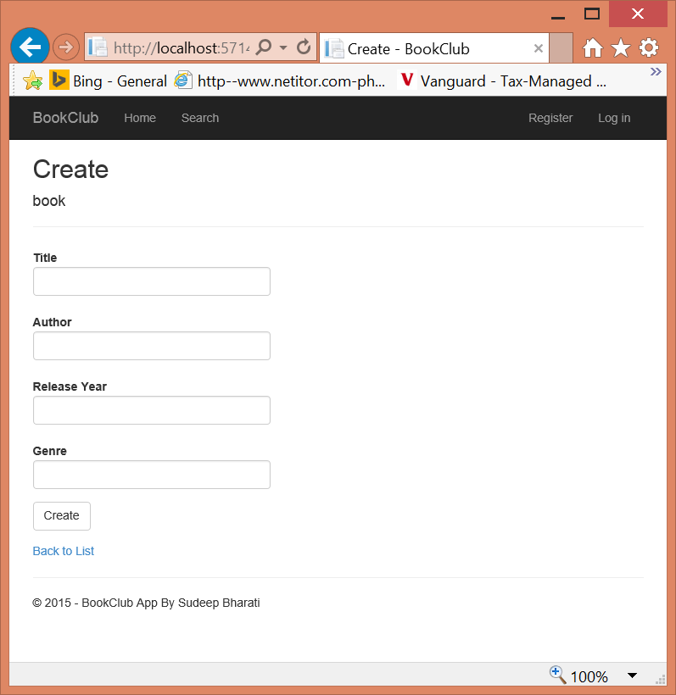

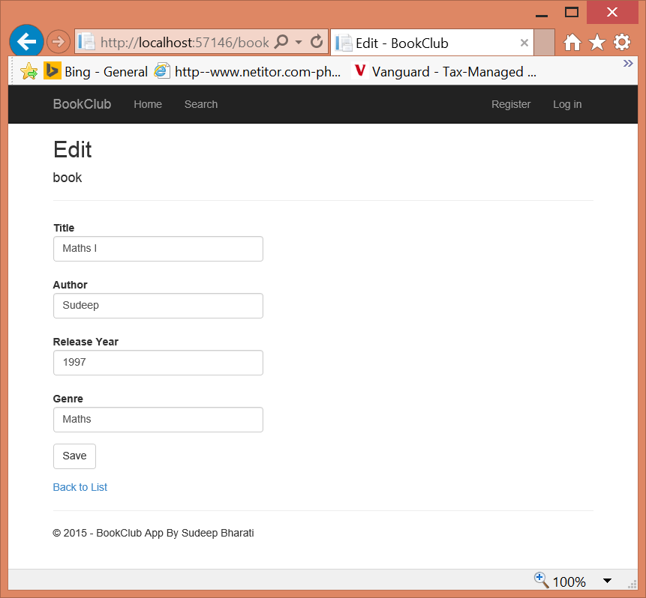

Both Create and Edit views after updating the changes take the user back to Home view.

Here is the Detail view of a book entry.

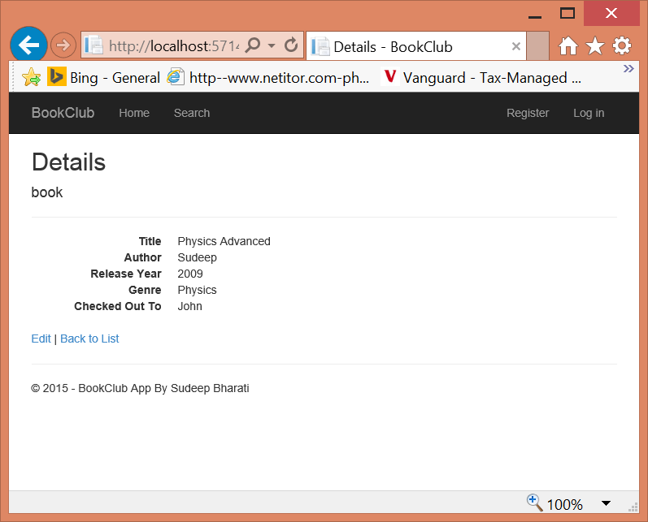

Here is the Delete view of a book entry. After confirming with the user and deleting the book, the user is taken back to the Home view.

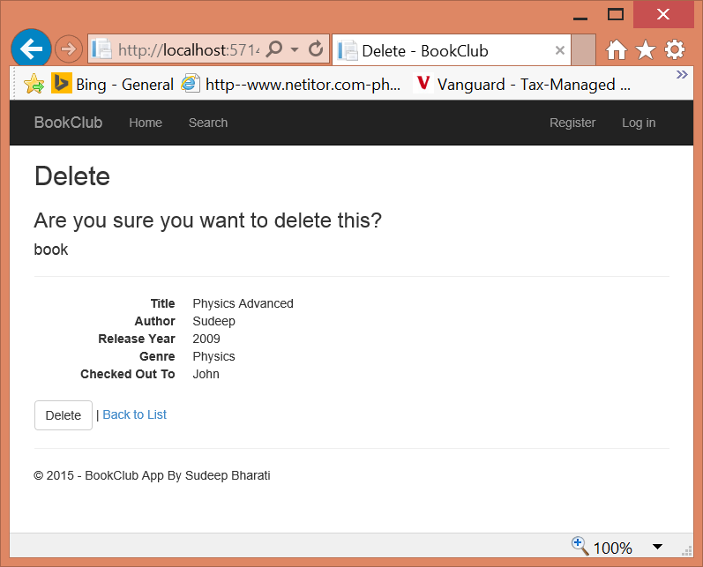

Search Menu brings the user to the below view where by default all the books are shown along with a textbox to filter the books given a query string for the Book Title field. The filtering finds every book that has the given query substring (case insensitive).

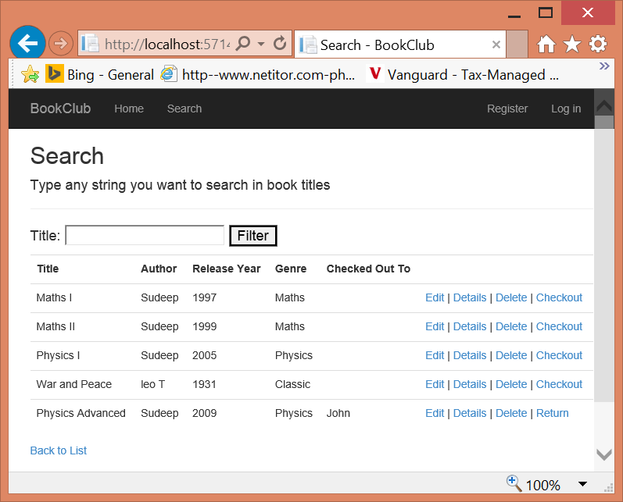

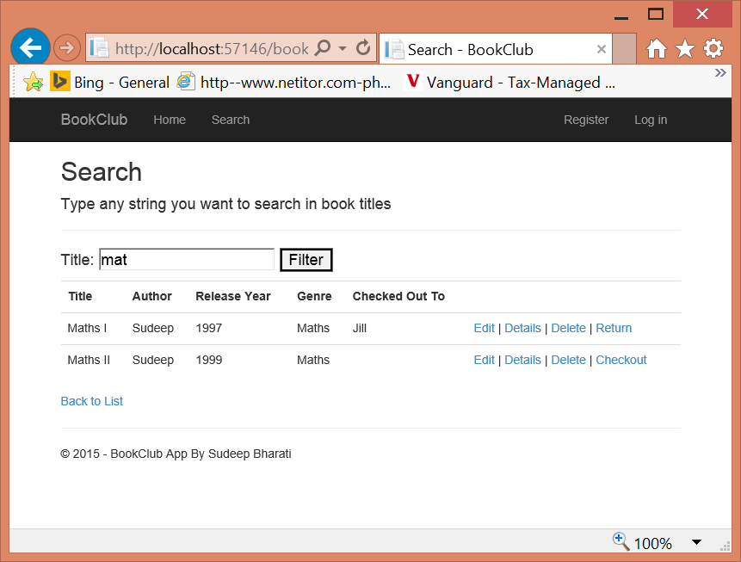

**Submission**: Upload your compressed solution with the canvas quiz entry. Insert your name in the compressed folder name. Add a .txt file to your project before compressing listing the browser you used if other than IE 11, to test your work as well as anything else I should know.

**Grading Criterion**:

1. 60% for working functionality within a browser (IE 11 is default choice I will use to grade)
2. 30% for code quality and using MVC properly
3. 10% general cleanliness and appropriate comments